Vectors Quiz Answer Key
Note: Vector quantities are shown in italics.
- If Burt walked 3 miles North and then 4 miles East, how far is he from his starting point?
Burt is 5 miles away from his starting point. d = 5 mi

- Using Figure 1 as a guide, which could be possible vectors for the ball at point B?
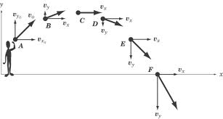
Source: http://img.sparknotes.com/content/testprep/bookimgs/sat2/physics/0012/projectile.gif
Figure 1: A person throws an object up and to the side. Use this figure to answer question 2. Not to scale.

- v_{x} = 2 m/s, v_{y} = 2 m/s
- v_{x} = 5 m/s, v_{y} = 2 m/s
- v_{x} = 2 m/s, v_{y} = 5 m/s
- v_{x} = 5 m/s, v_{y} = 0 m/s

- A Football player punts the ball, first at an angle of 30º from the ground, and then at an angle of 60º from the ground. Using vectors to describe the trajectories, which of the following is true about the initial velocity?
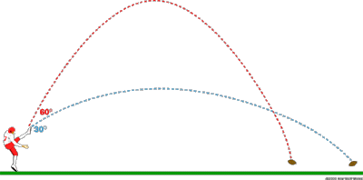
Source: http://static.ddmcdn.com/gif/physics-of-football-kick.gif

- The initial velocity of the punt that was 30º from the ground has a larger x-component
- The initial velocity of the punt that was 30º from the ground has a larger y-component
- Both would have the same y-components
- Not enough information
- Using the same figure as in question 3, what could the punter do to make sure the ball travels farther across the field?
- Increase the initial velocity
- Increase the y-component
- Increase the x-component
- All of the above
- a and c only

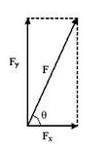
Source: Image courtesy of http://physics.about.com/od/mathematics/a/VectorMath.htm
Figure 2: Vector quantity F, with components F_{x} and F_{y}. Use this figure to answer questions 5-8.
- If F_{x} = 13 N and F_{y} = 25 N, calculate the magnitude of F.

28.17 N

- If F = 22 Newtons and the angle between F_{x} and F is 30º, what are F_{x} and F_{yƒ}?

F_{x} = 19.05 N, F_{y} = 11 N

- If F = 100 Newtons and the angle between F_{x} and F is 45º, what are F_{x} and F_{yƒ}?

F_{x} = 70.7 N, F_{y} = 66.9 N

- If F_{x} = 15 Newtons and the angle between F_{x} and F is 60º, find F and F_{yƒ}.

F_{y} = 30 N, F = 25.98 N

- A catapult launches a clown off the ground at an angle of 15º from the horizontal. The clown’s initial velocity once he left the catapult is 30 m/s. What are the x and y components of the clown’s initial velocity?

v_{x} = 28.98 m/s, v_{y} = 7.76 m/s

- Pablo Sandoval hits a pop-fly with his baseball bat so that the ball goes high up in the air, at an angle of 80º from the ground. The ball started traveling at 98 mph, which is about 43.8 m/s.
a. What are the x and y components of the baseball’s initial velocity right after it leaves his bat?

v_{x} = 7.61 m/s, v_{y} = 43.13 m/s

b. In one or two sentences, explain which vector is larger and why that makes sense for this problem.

The y-component of the initial velocity is larger because the ball went straight up in the air, and did not travel very far sideways along the level of the ground. When the angle is large like on a pop-fly, there is more of a y-component because the y-axis is vertical.

