Types of Waves Quiz Answer Key
1. Name three characteristics that all waves have.
Period, wavelength, amplitude, repeating motion
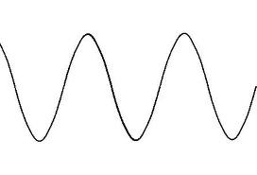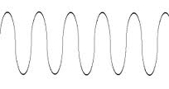

Image Source: http://www.thehelper.net/threads/creating-a-sin-wave-in-opengl.155695/
Image Source: http://lwjgl.org/wiki/index.php?title=OpenAL_Tutorial_7_-_The_Doppler_Effect
Figure 1: The figure on the left is Wave A and the figure on the right is Wave B. Use these two waves to answer questions 2-4. Assume they are on the same x and y axes of time and displacement, respectively.
2. Which of these waves has a larger amplitude?
Wave A
3. Which of these waves has a higher frquency?
Wave B
4. Which of these waves has a longer wavelength?
Wave B

A--------------------------------------------B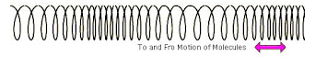
Image Source: http://efy-kebersihan.blogspot.com/
Figure 2: A wave on a spring. Distance between point A and point B is 3 meters. Use this figure to answer questions 5 and 6.
5. Figure 2 is an example of what type of wave?
longitudinal
6. If the distance between point A and point B is 3 meters, what is the wavelength of the wave in figure 2?
3 meters
7. The speed of a wave depends on:
a) The wavelength of the wave
b) The amplitude of the wave
c) Whether it is transverse or longitudinal
d) The medium through which the wave is traveling
8. At a Forty Niners game, the crowd goes wild and does “the wave” by standing up and raising their hands as the wave is passed around the seats. What kind of wave is this an example of?
Transverse
9. What type of wave is formed by a jump-rope?
Transverse
10. Explain why sound is considered a longitudinal wave.
Sound is vibration of molecules in the air that pass pressure side to side, parallel to the direction of motion.

