Types of Forces Quiz Answer Key
1. Which of the following is NOT a force?
- Gravity
- Inertia
- Normal
- Tension
2. If a book sits on a table, in what direction does the Normal force act?
Upwards
3. You are pushing on a wall with 20 N of force. What type of force pushes back on you, and what is its magnitude?
Normal force, 20 N
4. What is the root cause of the normal force?
- Gravity pulling on you
- It is a force that is normal because it occurs for all objects
- Electromagnetic repulsion of atoms
- None of the above – it simply exists
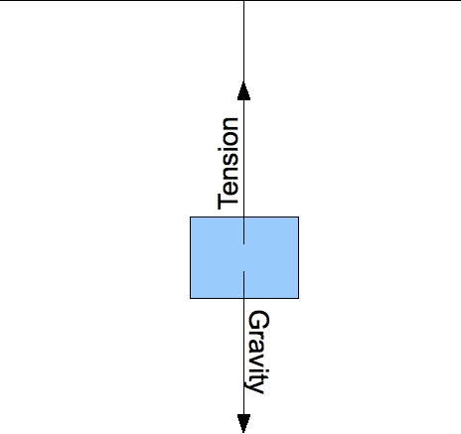
Figure 1: Consider a hanging block. Assume the object is in equilibrium. Use this figure to answer questions 5 and 6.
5. Using Figure 1, write an equation of forces acting on the hanging block.
Tension = F_{gravity} or T = mg
6. What is true about the tension at the bottom of the rope as compared to the tension at the top?
The tension is equal throughout the rope
7. What determines the magnitude of the force of friction between two objects?
- The normal force
- How much surface area is in contact
- How quickly the two objects are sliding past each other
- All of the above
- a and b only
8. What is the factor that determines the elastic force of a particular spring?
The spring constant, K
9. If a sled is being pulled along the ground at a constant speed, what is true about the friction force?
- It is zero
- It is opposite the pulling force
- It is equal in magnitude to the pulling force
- All of the above
- b and c only
10. Name one difference and one commonality between the two types of friction.
Kinetic friction is the friction between two moving objects, while static friction is the friction between two non-moving objects
Kinetic friction is smaller or easier to overcome than static friction
Kinetic and static friction both depend on the surfaces of the two objects in contact

