Total Internal Reflection Quiz Answer Key
Key Equations
n_{air} = 1
n_{water} = 1.33
n_{oil} = 1.53
1. Total internal reflection is possible when
a) A wave is entering a medium with a higher index of refraction
b) A wave will partly reflect and partly pass through a medium
c) A wave is starting fast and then will slow down in the new medium
d) A wave starts out slow and encounters a medium where it can travel faster
2. What two pieces of information are necessary to find the angle that will create total internal reflection at the border of two mediums?
The index of refraction of both media
3. What is the angle of total internal reflection between water (n=1.33) and air (n=1)?
ø = 48.75º
4. You have a laser pointer and a tank filled half with water and half with oil. Considering your answer to question 1, decide from which medium into which medium you should shine the laser to create total internal reflection.
From water into air, or from oil into water
5. Consider your set up from question 4. If you shine the laser from the oil into the water, at what angle will it completely reflect and not refract into the water?
ø = 60.38º
6. Draw a diagram of the situation from question 4 including the path of the beam traveling from the air into the oil, and then from the oil into the water, where it experiences total internal reflection. Remember that Snell’s law applies for both.

Answer:
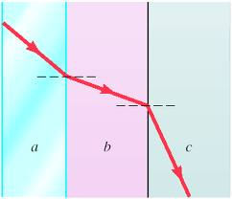
a= air, b=oil, c=water (in actuality the angle from b to c would be much larger (about 60º).
Image Source: http://www.chegg.com/homework-help/questions-and-answers/refracting-mediums-drawing-shows-ray-light-traveling-materials-surfaces-parallel--refracte-q1672832
7. Using your diagram and your answer from question 5, determine the angle at which you would need to shine the laser from the air into the oil to cause total internal reflection at the border between oil and water.
Ø = 49.13º
n₂
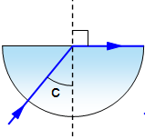
n₁
Figure 1: A beam of light from one medium into another. Use this figure to answer questions 8.
8. Consider the image in figure 1. What must be true about the indexes of refraction of the media?
a) n₁ > n₂
b) n₂ > n₁
c) n₂ = n₁
d) Not enough information
9. A light source is at the bottom of a fish tank. If you want to avoid seeing the light, where should you situate your eyes so as to avoid any refraction?
Close to the level of the water, not very high above the tank
10. You want a laser to follow the path of a coiled material at angles of up to 40º. What must be the index of refraction of the material in order for the light to stay within it and not get refracted into the air around the coil?
n₁ = 1.56

Sources:
Fig 1: http://www.schoolphysics.co.uk/age11-14/Light/text/Total_internal_reflection/index.html

