Specific Heat and Phase Change Quiz Answer Key
Key Equations
1 cal = 4.184 Joules

1. Using what you know about specific heat, explain why the San Francisco Bay Area does not have much fluctuation in its temperature throughout the year.
It is surrounded by water, which does not change temperature very easily due to its very high specific heat.
2. Put the following in order of lowest to highest specific heats: water, air, metal.
Metal, water, air
3. What determines whether an object has a high heat capacitance or a low heat capacitance?
How freely its molecules can move within the substance.
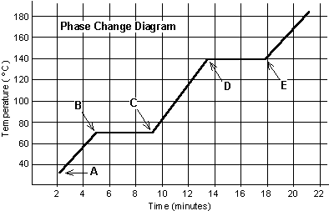
Image Source: http://www.felloweducators.com/brick/psc/_psca_phase_change_worksht.htm
Figure 1: This is the graph of the temperature of a solid substance as time passes. Heat is being added to the substance at a constant rate throughout the range of the graph. Use this figure to answer questions 4 through 6.
4. Using figure 1, why is the temperature of the solid not changing between 5 minutes and 9 minutes?
The energy supplied is being used to ‘melt’ or change the substance into a liquid.
5. Using figure 1, why is the temperature not changing between point D and point E?
The energy supplied is being used to boil the liquid into vapor.
6. What is the name of these ranges when heat is added but is not increasing the temperature of the substance?
Phase changes
7. Explain how you would find the melting point and boiling point of an unknown substance.
Measure and chart the temperature of the substance as time goes on; measure the temperature of the substance during a time when the temperature does not change but the object is going through a phase change of solid to liquid or liquid to gas, respectively.
8. If I add the same amount of heat to two different objects, why would they have different temperatures?
- Some objects heat up faster than others; their specific heat is different. Like metal compared to water.
- All heat transfer is not exact. It’s impossible to add the same amount of heat to two things.
- Objects have different mass. For example, if I add 10 Joules of heat to a swimming pool as opposed to 10 Joules of heat to a cup of water, the cup of water will have a higher temperature because there is less mass to heat up.
- Both a and b.
- Both a and c
9. Denise has 400 grams of hot tea on her desk. You measured its temperature in the morning to be 80ºC. When you checked again at lunch, it was only 42ºC. If the specific heat capacity of the tea is 4.186 J/gºC, how much heat was transferred to the environment?
Q = mc∆T = 63,627 J
10. If it were possible to harness and eat the energy lost from the previous question, how many food calories would it provide you?
15,207.3 cal = 15.2 kCal
15.2 food calories

