Sound in a Tube Quiz Answer Key
Key Equations
for a tube closed at one end:
, where is always odd
for a tube open at both ends:
, where is an integer

v = 343 m/s (speed of sound in air)
1. At a closed end of a pipe a sound wave’s amplitude will be at a:
- Maximum (antinode)
- Minimum (node)
- No wave
- Depends on the pipe
2. Draw the first three harmonics of sound waves in this open pipe.
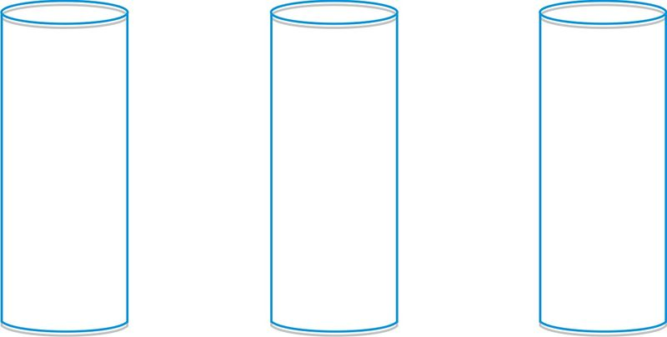
Image Source: http://www.ck12.org/concept/Sound-in-a-Tube/?ref=%2Fconcept%2FSound-in-a-Tube%2F
Answer:
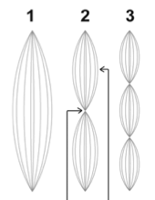
Image Source: http://www.cposcience.com
3. You blow across the top of an open, empty water bottle 20 cm tall. Draw a standing wave diagram for the fundamental resonance of the bottle and determine the fundamental frequency of the bottle.
425 Hz

Image Source: http://hyperphysics.phy-astr.gsu.edu/hbase/waves/clocol.html
4. Using the information from question 3, determine the next resonant frequency of the same bottle (the next harmonic). Draw the wave diagram and calculate the frequency.
1,275 Hz

Image Source: http://hyperphysics.phy-astr.gsu.edu/hbase/waves/clocol.html
5. If 5 cm of water were added into the bottle from question 3, would the fundamental frequency increase or decrease, and why?
The frequency would increase because the wavelength is getting shorter, therefore the waves would pass by more frequently.
6. An open pipe has a fundamental frequency of 225 Hz. Assume the speed of sound in air is 340 m/s. How long is the pipe?
L = 0.76 meters
7. If a tuba were straightened out, it would be 5.5 meters long! Find the lowest frequency of standing wave that is produced in an open tuba.
30.9 Hz
8. Consider the tuba from question 7. Draw and calculate the frequency of the 5th harmonic pattern produced inside of the tuba.
154.55 Hz
9. An experiment is conducted in class where students have a tube that is open on both ends, but submerged in water on the other end. They hold a tuning fork over the open end, move the pipe up and down, and wait to hear a loud resonant sound. If they hear the loudest tone when the water is 13 cm from the top of the tube, what is the frequency of the tuning fork?
653.85 Hz
10. If a wave’s fourth harmonic has a frequency of 400 Hz, what is it’s fundamental freuqency?
100 Hz

