Sound Quiz Answer Key
Key Equations
v = 343 m/s (speed of sound in air)
c = 2.9 x 10⁸ m/s (speed of light)
1. Explain why sound cannot travel in space.
Sound requires a medium because the definition of sound is a vibration of molecules through space (or air). With no molecules in space it cannot vibrate thus it cannot travel.
2. True or False: Sound is a longitudinal wave. ___True________

3. When a tuning fork is stricken against a table, it vibrates at a frequency of 300 Hz. At what frequency will you hear the sound of the tuning fork?
300 Hz
4. When you watch a basketball court from the top of a building one kilometer away, you see the ball bounce and after a short time delay, you hear the sound of the bounce. Explain this phenomenon.
Sound travels slower than light.
5. If a siren from the firehouse takes 0.2 seconds to arrive at your school, how far is your school from the firehouse?
68.6 meters
6. During a thunderstorm, you hear the thunder after the lightning. If the flash of the lightning comes at 7:47 and 28 seconds, and the sound of the thunder arrives at 7:47 and 41 seconds, how far away is the lightning strike?
4,459 meters away
7. Below is an image of a sound wave. Sketch a wave underneath it that represents the strength of the sound wave in the form of a sine wave.

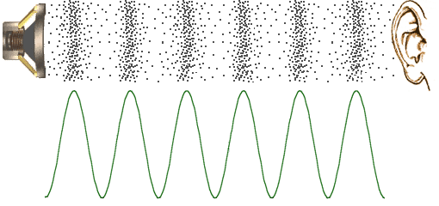

8. High pressure points on a sound wave are represented by
a) Peaks on a sine wave
b) Troughs on a sine wave
c) Nodes of a sine wave
d) Depends on the type of sound wave
9. An airplane is traveling at the speed of sound and honks its horn at an upcoming spaceship. Does the spaceship get the message in time?
No because the airplane is traveling at the same speed as the horn honking sound
10. Fill in the Blanks: Sound cannot travel through a _______vacuum_________. It requires a ________medium_________ through which it can vibrate.

Sources:
Image for Question 7: http://www.mediacollege.com/audio/images/loudspeaker-waveform.gif

