Resistors in Circuits Quiz Answer Key
Key Equations

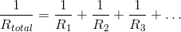

1. True or False: The total resistance in a circuit is equal to the sum of all of the resistors. ______False______
2. Choose the best answer.
a) In a series circuit, the current is the same throughout the loop
b) In a parallel circuit, the current is the same throughout the circuit
c) All resistors in a circuit experience the same voltage drop
d) All of the above are true
3. Fill in the Blanks with either “Series” or “Parallel.”
When calculating the total resistance of a circuit, it is easiest to first simplify all of the resistors that are wired in _____Parallel________, and then add all resistances that are wired in ______Series_______.

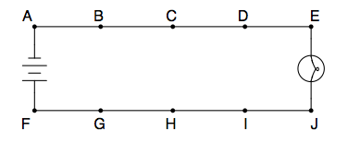
http://happygj.wikispaces.com/file/view/Simple+Circuit+for+AT+-+EEX+4763.pdf
Figure 1: A series circuit with a battery between points A and F and a lightbulb between points J and E. Use this figure to answer questions 4 and 5.
4. Consider the circuit in figure 1. To what two points would you connect a voltmeter to measure the full voltage of the battery?
Connect to A and F
5. Consider the circuit in figure 1, and assume the lightbulb between points E and J has a resistance of 10Ω. What could you do to this circuit create a total resistance of 3/5 Ω?
Add two resistors in parallel; one with resistance 6Ω and one with resistance 3Ω
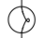
6. Draw the schematic diagram for the following circuit: One battery and one light bulb wired in series, with a parallel branch of two resistors, and a parallel branch off of one resistor with a third resistor.

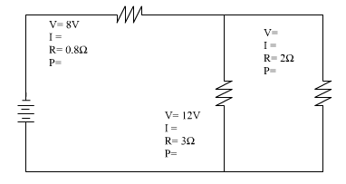
Image Source: http://www.docstoc.com/docs/5630564/Mixed-Circuit-Diagrams-Hints-Simplify-the-circuits-Try-and
Figure 2: A circuit with both series and parallel elements. The resistor at the top, called R1, has a voltage drop of 8V and a resistance of 0.8Ω. The middle resistor, called R2, has a voltage drop of 12V and a Resistance of 3Ω. The outermost resistor on the right, called R3, has a resistance of 2Ω. The battery is all the way on the left. Use this image to answer questions 7 through 10.
7. What is the total resistance of this circuit?
R_{tot} = 2Ω
7. Using the information from figure 2, what is the voltage across R3, the outermost resistor?
V3 = V2 = 12V
8. Using the information from figure 2, what is the total current running out of the voltage source?
I = 10 amps
9. Using the information from figure 2, what is the current through each of the three resistors?
I1 = 10 amps
I2 = 4 amps
I3 = 6 amps
10. Using the information given in the figure, what is the power dissipated by each of the three resistors?
P1 = 80 Watts
P2 = 48 Watts
P3 = 72 Watts

