RC Time Constant Quiz Answer Key
Key Equations
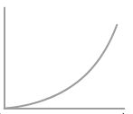
1. Which of the following is the most accurate graph for the relationship of charge being dissipated out of a capacitor versus time?
A. 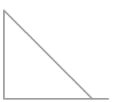 B. 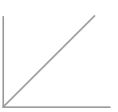
C. 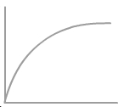 D.

Image Source: http://www.bbc.co.uk/bitesize/higher/physics/mech_matt/analyse_motion/revision/1/

2. Explain why the time it would take to discharge half of the capacitor’s charge is NOT equal to half of the total time.
This is not a linear relationship; it is logarithmic. More charge is lost at the beginning of the discharging process.
3. A capacitor is used to store charge for a disposable camera flash. One second after the flash is operated, the charge left in the capacitor is 5 mC. If the capacitance is 0.08 µF and the resistance of the light bulb is 25 Ω, what is the initial charge right before the flash is operated?
Q₀ = 0.003 C
4. Using all of the information from question 4, what percentage of the original charge was left after 1 second?
60%
5. Using all of the information from question 4, what is the current after 1.2 seconds if the initial current right as the flash is operated is 2 A?
I(1.2s) = 2A (Q/Q₀) = 1.1 A
6. Find the time constant of a capacitor if after 5 seconds of discharge, it had 1/4 as much as the initial charge.
T = RC = 3.61 seconds
7. What are the conditions for finding the RC time constant of a particular capacitor?
RC =t, or The elapsed time must be equal to the product of the resistance and the capacitance

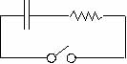
Figure 1: A circuit with a capacitor, a resistor, and a switch. The capacitor has capacitance 40 µF, the resistor has resistance 90Ω. Use this figure to answer questions 6-9.
8. Find the RC time constant for the circuit in figure 1.
RC = (90Ω)(40µF) = 36 sec
9. Say you flip the switch closed (Figure 1). After how much time will the capacitor in figure 1 have half of its initial charge remaining?
24.95 seconds
10. At what time will the current be one fifth (20%) of what it was when you initially flipped the switch? (Use Figure 1)
t = 57.94 seconds

