Problem Solving 1 Quiz Answer Key
For each question, remember to follow these steps.
Problem Solving for Newton’s Laws, Step-By-Step
- Figure out which object is “of interest.”
- Identify all the forces acting on the object and draw them on object. (This is a free-body diagram --FBD)
- Determine how to orient your axes
- Identify which forces are in the direction, which are in the direction, and which are at an angle.
- Break the forces that are at angles into their and components
- Add up all the forces and components.
- Add up all the forces and components.
- Use Newton's Laws twice.
- Each body should have a FBD.

1. Why does it take longer to solve mechanics problems that take place in more than one dimension?
You have to do two separate sets of equations, one for each dimension.
2. A 2-kg block is being pulled with a force of 10 N towards the right at a constant speed.
- Draw the free body diagram for this object.
Fgravity
Fpull
Ffriction
FNormal
2 kg

- Write an equation for each direction (x- and y-).
x-direction
Fpull – Ffriction = 0
y-direction
FNormal – Fgravity = 0
- Calculate the following:
F_{gravity} = mg = - 19.6 N
F_{Normal} = 19.6 N
F_{pull} = 10 N
F_{friction} = -10 N
3. A 12-kg computer cart is on an inclined plane of 30º from the horizontal.
y axis
FNormal
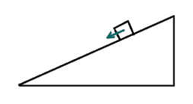
x axis
Fgravity
Ffriction
- Draw in all forces acting upon the cart.
- Use dotted lines to draw in the axes you will choose to solve this problem.
- Name all forces acting in the “x” direction.
Fgx, Ffriction
- Name all forces acting in the “y” direction.
Fgy, FNormal
4. The same computer cart is accelerating down the same 30º slope at 2 m/s². Using your answers from question 2, calculate the Normal force and the frictional force.
y
Fgy – Fnormal = 0
Fgy = (12-kg)(10m/s²) cos30 = 103.9 N
Fnormal = -103.9 N
x
Fgx – Ffriction = ma
(12-kg)(10m/s²) sin30 – Ffriction = (12kg)(2m/s²)
60 N – Ff = 24 N
Ff = -36 N
5. Cinderella is sitting in her carriage as her horses pull it at a constant speed. The ropes that are tied to the carriage form a 26º angle with the horizontal. As the horses run, air resistance causes a backwards force of 3 N, and the frictional force is 128 N. With how much force are the horses pulling the ropes?
x-direction
Fx – (Ff + Fair) = 0
Fx = 131 N
Fx = Fcosø
F = 145.75 N
50N – 20 N = (2kg)a
a = 15 m/s² upwards
m₁
m₂
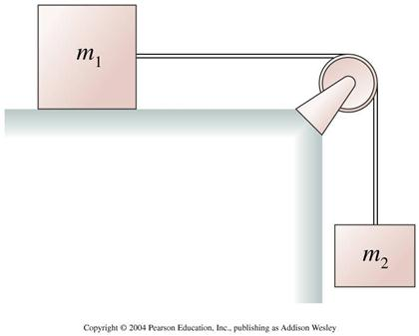
Figure 3: Imagine a block m₁ on a table with another block m₂ hanging from a string over the side of the table. Use this figure to answer questions 6, 7, and 8. Assume the pulley has negligible mass.
6. If m₁ = 3 kg and m₂ = 2 kg, calculate the acceleration of block m₂. Assume no friction or air resistance.
Write F=ma equations for each block, set the tension of the string on each block equal to each other, solve for a (a₁ = a₂)
a = 4 m/s²
7. Consider Figure 3 and assume m₁ = 3 kg and m₂ = 2 kg. Say the side of the table is actually slanted so that instead of dropping at a right angle, the side makes a 30º angle with the horizontal. The string holding m₂ is parallel with the table, and the block m₂ is sliding down the 30º ramp. What is the acceleration of the block m₁? (Assume no friction or air resistance.)
Same equation as previous problem, just change the downwards force into a force in the direction of the ramp, or F = mgcosø. The block will not move in the “vertical” direction perpendicular to the ramp.
a = 3.46 m/s²
8. Consider the same situation as described in the previous problem. This time, assume the frictional force between m₂ and the slope is Ff = 8 N up the slope. If the system is at rest (a=0m/s²), find the force of tension in the rope.
Forces acting down the ramp: F_{g} = mgcosø
Forces acting up the ramp: T, F_{f}
m₂a = 0 = m₂gcosø – T – F_{f}
T = 9.32 N
9. Consider the diagram of a hanging lamp below. The angles of the string with the horizontal are θ₁ = 60º and θ₂ = 30º. The lamp is 40 kg. Find the tension in both strings, T1 and T2.
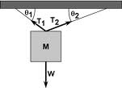
Image Source: http://media.cheggcdn.com/media/537/5370b2f2-dc76-4f01-848c-b9aaa0c132eb/phpaN7cyN.png
x-direction:
T₁cosθ₁ + - T₂cosθ₂ = 0
y-direction:
T₁sin θ₁ + T₂ sinθ₂ – mg = 0
Solve this system of equations.
T1 = 346 N
T2 = 200 N
10. Imagine a lamp just like in the previous question, but with three strings holding it up in three different dimensions. Describe how you would set up a system of equations that would allow you to find the tensions in each of the three strings. You do not have to set up the equations.
Call the third dimension “z.” Create the same set of equations set up for the previous problem, but add another term in each equation that showed the force of the third rope’s tension pulling in the z-direction. Create another equation for the z-direction that included the forces pulling in the + and – directions of z. With three equations and 3 unknowns (T₁, T₂, and T₃), solve the system of equations.

Sources:
Question 2 image: By author
Question 3 image: http://vhcc2.vhcc.edu/ph1fall9/pictures/mass_on_incline.htm
Figure 3: http://www.chegg.com/homework-help/questions-and-answers/-if-we-neglect-the-friction-between-m1-and-table-the-pulley-mass-is-mp-i-what-is-the-accel-q1081397
Question 9 image: http://media.cheggcdn.com/media/537/5370b2f2-dc76-4f01-848c-b9aaa0c132eb/phpaN7cyN.png

