Pressure in Fluids Quiz Answer Key
Key Equations
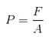
1. Why is liquid used in a piston more often than air?
Liquids are usually not compressible and therefore transfer all the force.
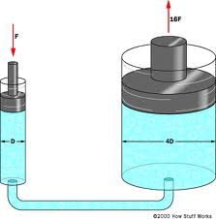

Figure 1: A system of two pistons that are attached by a tube of water. Use this image to answer questions 2-4. Ignore any numerical labels in the figure.
2. Consider the piston in Figure 1. If you want to lift an object using the least amount of force possible, should you put the object onto the small end of the piston or the large end to be lifted?
Large end, you want to push on the small end.
3. Your mechanic is using the lift in Figure 1 to lift your 2000 kg car. How much force would you need to apply to the smaller piston with diameter 0.5m in order to lift your car, which is sitting on the right side piston with diameter 2-meters?
F = 12261 N

4. Why is it difficult to hold an inflated beach ball underwater when it can easily float on the surface of the water?
As it goes deeper, there is a large force of water pushing down on the ball, therefore prompting a larger buoyant force upwards from the rest of the water which is uncompressible.
5. If liquid were more compressible, what would change about trying to hold an inflated ball under water?
It would be easier because the force you used to put the ball under the water would go to compressing the water beneath the ball and the ball would stay where you put it.
6. How much water pressure does a scuba diver feel if she is a distance of 20 meters under the water, not including atmospheric pressure?
P = 200,000 N/m² = Pa
7. How does the pressure of being 20 meters under water compare to atmospheric pressure?
Atmospheric / P_{20m} = about 2 times more
8. Consider your answer to question 6. How does this pressure change if she doubles her depth in the water?
It doubles
9. About how much force is acting on the palm of your hand due to atmospheric pressure?
If r =4 cm, A ~ 0.0048 m², F = (101.3 kPa)(0.0048 m²) = 486.24 N

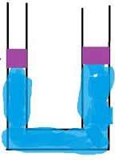
Figure 2 Simple double piston system, coupled. Assume equal sized pistons.
10. You have a double piston system like the one pictured in Figure 2. Imagine one of the pistons is in an enclosed room, and the other piston is exposed to the normal atmosphere. What would happen if you turned up the pressure in the enclosed room where the first piston is?
The room pressure would push the water out of the tube and over flow into the other piston.

Sources:
Fig 1: http://www.asparis.net/lowerschool/4thgrade/simple%20machines/Howstuffworks%20How%20a%20Block%20and%20Tackle%20Works2.htm
Fig 2: http://physics.stackexchange.com/questions/37583/pascal-law-with-two-connected-cylinders-filled-with-water-and-50kg-stones-at-bo

