Pressure and Force Quiz Answer Key
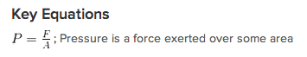
1. Using the concept of pressure, explain why a thumbtack has one sharp side to go into the wall and one wide side for your thumb.
The small area of the sharp side means that all of the force from your thumb is concentrated on one spot, thus the pressure is much higher than it is on the side with your thumb.
2. Amber and Isao were married outdoors on the grass. Why would Amber’s high heels sink into the ground farther than Isao’s flat-bottom shoes?
High heels have a smaller area thus the pressure is larger.
3. Matt hit the piñata with a 1-foot long, 3-inch wide portion of a bat. He used a force of 45 pounds. How much pressure did the bat exert on the piñata? (Assume the stick hits flat against the piñata.) Give your answer in pounds per square inch.
P = F/A = 45 lbs / 36 in² = 1.25 pounds per square inch of pressure (psi)
4. Which of the following statements is NOT true about pressure?
- Pressure can be measured in Newtons
- Pressure can be measured in Pascals
- Pressure depends on the force
- Pressure depends on the area
5. A water tower is 18 meters high and has a diameter of 6 meters. If there are 400-kilograms of water in the tank, what is the pressure exerted on the bottom of the tank?
F = mg = 4000N
A = πr² = (3m)² π = 29.27 m²
P = F/A = 136.66 Pa
6. Explain why a physics teacher would feel comfortable laying on a bed of 100 nails, but would refuse to lay down on one nail?
The physics teacher knows that although one nail’s surface area is so small that the pressure is large enough to pierce the skin, multiplying that area by 100 times would spread the force out evenly and the pressure would not be high enough to hurt her.
7. A four-sided crystal pyramid (with triangular sides) sits as a centerpiece. It is 1cm high and has sides that are 2cm each. If it has a mass of 0.6 kg, what pressure is it exerting on the table?
A = ½ bh = 1 cm² , F = 6 N
P = 6 Pa
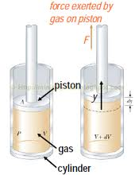
Figure 1: Piston and cylinders inside of a car. Use this figure to answer question 8.
Image Source: http://3.bp.blogspot.com/-hgd7aQMOmHI/TtYphso5xZI/AAAAAAAABC4/9OB0SQdb9tM/s1600/Gas+piston.png
8. A 6-cylinder Cadillac has pistons that are 4-inches in radius. If the pressure is 150 psi for each piston, how much force is the car providing for all the pistons?
F = P•A = 150 lbs/in² / 16π = 2.984 lbs per cylinder x 6 cylinders
F = 17.9 pounds
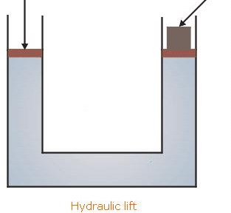
Dog
Heavy weight
Figure 2: Hydraulic lift. Use this figure to answer question 9.
Image Source: http://www.tutorvista.com/content/physics/physics-iii/solids-and-fluids/pascals-law-applications.php
9. A hydraulic lift is used to save a dog from being trapped inside of a 2-meter wide cylindrical well (see Figure 2). If the dog’s mass is 12-kg, what pressure is needed to push on the other side of the lift?
A = (1m)²π, F = mg = 120 N
P = 38.2 Pa
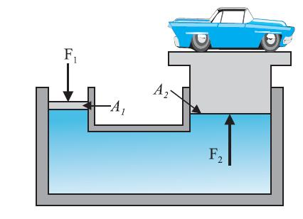
Figure 3: A car being lifted at a mechanic. A piston is used to push down the liquid on the smaller cylinder 1, while the car rests on the larger cylinder 2.
Image Source: http://1.bp.blogspot.com/_lSeHUTv3pHI/TAd33-JYobI/AAAAAAAAABc/TpZJ-Tb5bpQ/s1600/Physics+3.JPG
10. A car at the mechanic is lifted by a dual-piston system. The area of the first cylinder is 2 m², and the area of the second cylinder where the car rests is 5m². What force F₁ would be required to lift the car if its mass is 2000-kg? (Hint: Use what you know about the pressure of a liquid)
F₁ / A₁ = F₂ / A₂
F₁ / 2 m² = 20,000 N / 5 cm² F₁ = 8000 N

