Position and Displacement Quiz Answer Key
1. A lizard ran 3 meters from his rock to his friend’s house. He ran back halfway and stopped.
- What is his displacement?
1.5 m
- What is his distance traveled?
4.5 m
2. Billy drove to Los Angeles and back. What was his displacement?
Zero
3. Draw two different paths between the two dots below. Draw one path that shows the displacement between them and one that shows a different path. Label both.
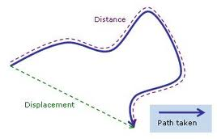
4. Which of the following is NOT true about an object over a given amount of time?
- Its displacement can be larger than its distance
- Its distance can be larger than its displacement
- Its distance can be equal to its displacement
- It can have a non-zero distance and have zero displacement
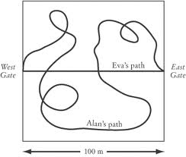
5. Using the Figure above, answer the following questions.
- Who has a larger distance, Eva or Alan?
Alan
- Who has the larger displacement?
Neither – they have the same displacement of 100 m.
- Who would have to travel faster on their path in order to reach the East gate at the same time as the other person?
Alan would have to travel faster to reach the East gate at the same time as Eva
6. When you want to buy a car with low mileage, do you need to know its displacement or its distance traveled? Why?
Distance traveled
7. A lost dog wanders the streets trying to find her home. She traveled 15 blocks north, 5 blocks West, and 3 blocks south.
5 blocks
- Draw a picture of her path and label each distance.
3 blocks
15 blocks
- What is her total distance traveled?
23 blocks
- What is her total displacement?
13 blocks (in red – use Pythagorean Theorem)
8. Say the tortoise and the hare are racing. If the tortoise moves straight backwards from the starting point, what is true about its displacement?
- Its displacement is zero
- Its displacement is larger than its distance
- Its displacement is negative
- None of the above
9. Describe a path that has zero displacement but a non-zero distance.
A man who walked in a circle (or anything that ends up where it started)
10. Displacement is a vector that depends on
- Time
- Direction
- Position
- All of the above

Challenge
11. John is on the edge of a merry-go-round that travels in a perfect circle. After going exactly halfway around, he measured his total distance traveled to be 37.7 meters. What is his displacement from the starting point?
d = 37.7 m = half the circumference = ½ (2 π R)
πR = 37.7 m
R = 12 m
2R = displacement = 24 meters

Sources:
Question 3 Answer image: http://excelmathmike.blogspot.com/2010_09_05_archive.html
Question 4 Figure: http://img.sparknotes.com/content/testprep/bookimgs/sat2/physics/0005/Eden.gif
Question 7 image: By author

