Period and Frequency Quiz Answer Key
Key Equations
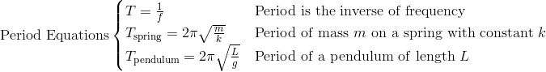

1. What combination makes sense for an object experiencing harmonic motion?
a) Period is 3 seconds and frequency is 0.33 Hz
b) Period is 10 seconds and frequency is 5 Hz
c) Period is 18 seconds and frequency is 1.8 Hz
d) Period and frequency are not related
2. A radio station broadcasts at 500 KHz. What is the period of the radiowave?
0.000002 seconds or 0.002 ms
3. A cephied-variable star is one that rotates at a fixed period. The luminosity of Polaris, our North star, rises and falls 119 days. What is its rotational frequency?
1/119 Hz = 0.0084 Hz
4. A rubber duckie is fixed to the end of a slinky held off the side of a roof. It bounces up and down, and when it is at its lowest point the woman in apartment 205 can see it. If the woman saw the duck 9 times in the course of one minute, what are the period and frequency of the rubber duck?
T = 7.5 seconds, f = 0.15 Hz
5. A child jumps on a trampoline once every two seconds. What is her frequency?
½ Hz
6. The same child from question 5 stops jumping but continues to bounce up and down until she slowly stops moving. What would the graph of her height look like? Describe it with words and sketch it.
It would look like a sine wave whose amplitude shrinks over time.
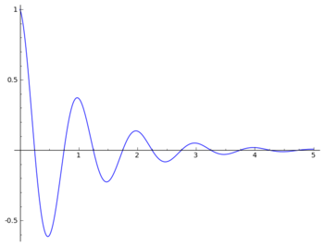 (Answer to #6)
Image Source: http://upload.wikimedia.org/wikipedia/commons/2/25/DampedSine.png

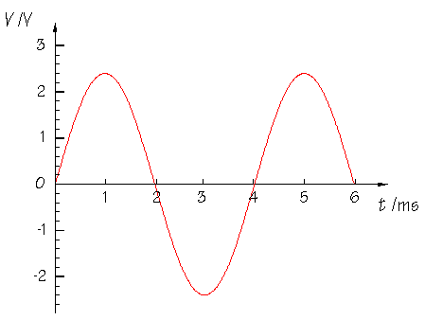
Image Source: http://www.doctronics.co.uk/check4.htm
Figure 1: A sine wave of an object in harmonic motion. The x-axis measures time in milliseconds, the y-axis measures displacement. Use this figure to answer questions 7 through 10.
7. Using Figure 1, what is the period of the object that would make this graph?
T = 4 seconds
8. What is the frequency of the object that made the graph in Figure 1?
f = 0.25 seconds
9. What percentage of a full wavelength occurs in the span of one second?
25%
10. Compare the answers for questions 9 and 10. Explain how they are related and why.
One whole period happens in 4 seconds, so a quarter of a period happens in ¼ of a second.

