Pendulum Quiz Answer Key
Key Equations
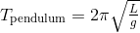

1. Fill in the blanks: As the pendulum gets longer, the period of the swing gets ___longer_____.
2. On the moon, the acceleration due to gravity is 1.6 m/s². Calculate the difference in the period (the ratio) of two identical pendulums if one were on Earth and one on the Moon.
The pendulum on the Earth would swing 2.47 times faster than the Pendulum on the moon.
3. If a pendulum has a length of 1.8 cm, what is its period?
2.69 seconds
4. Two pendulums swing from the same point. When dropped at the same time from the same height, they swing at different rates and meet up again when the shorter pendulum has completed 18 full cycles and the longer pendulum has completed 10 full cycles. If the long pendulum has a length of 2 meters, what is the length of the short pendulum?
L₁ = 0.62 meters
5. A grandfather clock must have a period of 1 second in order to keep time. What length pendulum would be necessary to do this?
L = 0.5 meters
6. You and your friend Joe are filming a music video. Joe has a spring with spring constant 9.8 N/m and a 0.2-kg mass hanging from the end, resulting in harmonic motion. You want the metronome to match the period of the bouncing spring. How long would your metronome’s pendulum have to be?
L = 0.2 meters

7. If Sandy quadroupled the length of a pendulum, the period would be
a) Doubled
b) Four times as long
c) Cut in half
d) Not enough information
8. As gravity works on a pendulum, it slows down due to the force. How many full cycles could a 2-meter long pendulum complete if it took 4 minutes for the pendulum to stop completely?
84.55 cycles in 4-minutes
9. A pendulum is painted in ink so that it will make a mark along its path. Once you let go, it takes the pendulum 0.8 seconds to reach the bottom of its path. What is the farthest distance from the pivot point to the mark of the pendulum?
L = 0.8 meters
10. Below is the graph of a pendulum’s displacement over time. Estimate the period and the length of this pendulum.
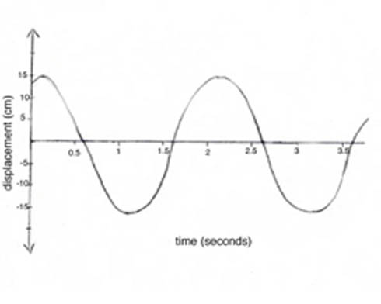
Image Source: http://schools.wikia.com/wiki/Simple_Harmonic_Motion
T = 2 seconds
L = 1 meter

