Moment of Inertia Quiz Answer Key
Key Equations
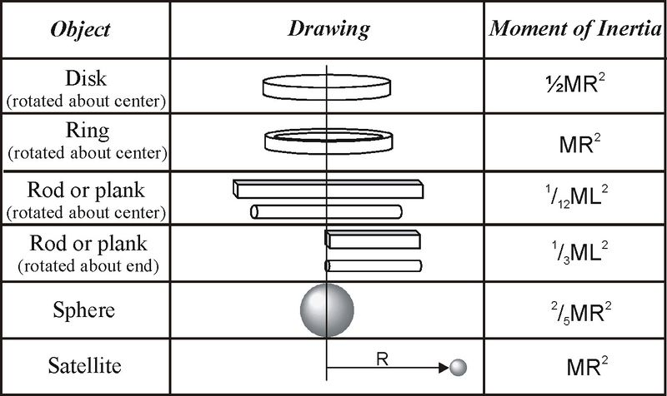
1. The Moment of Inertia depends on what two qualities of the object?
Mass and distance from rotational axis
2. What would affect the moment of inertia of a pole more; doubling the mass or doubling the distance of the mass from the axis of rotation? Explain why.
Doubling the distance from the center would affect the moment of inertia more because the radius term is squared in the equation.
3. What is the moment of inertia of a bike wheel if the mass of the bike tire is 0.2-kg and the diameter of the wheel is 40 cm?
I = 0.008 kgm²
4. The 8-ball is spinning in place on the pool table. If normal pool balls have a mass of 0.16-kg and a diameter of 57.15mm, what is the moment of inertia of our 8-ball?
I = 0.0000523 kgm²
5. The cue ball used in billiards (pool) is 0.01-kg heavier than the numbered balls, though they are usually the same size. Using the information from question 4, calculate the change in moment of inertia for the numbered balls as opposed to the cue ball.
I_{number}/I_{cue} = 0.0000523 kgm²/0.00005557 kgm² = The numbered balls have 94% of the cue ball’s moment of inertia.
6. A barbell has 990-kg weights on each end of the pole. The pole itself is 8-kg and 1 meter long. What is the moment of inertia if a weight-lifter tries to spin it around the center of the barbell?
I_{pole} + I_{weights} = 1/12 (8kg)(1m)² + (990kg)(0.5 m)² + (990kg)(0.5 m)²
I = 495.66 kgm²
7. Using the information from question 6, what is the moment of inertia of the barbell if the weight lifter tries to swing it around by one end?
I = 992.66 kgm²
8. You are building a soap-box car. If you want it to roll down a hill faster and with less force, should you make the wheels hollow like rings or filled like disks?
Filled like disks because the moment of inertia will be lower and it will be easier to spin.
9. A ring-shaped weight with a radius of 40-cm is being spun around its center axis for a physics demo. If experiments show that its moment of inertia is 0.4 kg-m², what is the mass of the ring?
m = 1 kg
10. Re-calculate the moment of inertia of the ring from question 9, but this time assume the weight is spherical. Compare the two moments of inertia and justify the difference.
I = 0.16 kgm²
The moment of inertia of the spherical weight is much smaller than the moment of inertia of the ring because its mass is spread more evenly throughout the weight and is closer to the center spinning axis.

