Lorentz Force Quiz Answer Key
Key Equations
q+ (proton) = 1.6 x 10⁻¹⁹ C
q - (electron) = - 1.6 x 10⁻¹⁹ C
1. What four factors determine what force a particle will feel due to a magnetic field?
The charge of the particle, the velocity of the particle, the strenght of the magnetic field, and the angle at which it is traveling with respect to the magnetic field.
2. What three vectors are always perpendicular to each other in the case of a moving particle through a magnetic field?
The velocity (direction of motion) of the particle, the magnetic field lines, and the force on the particle due to the lines.
3. Say a proton was zooming West at a speed of 8x10⁷ m/s. What force would it feel if it was moving parallel to the Eastward-pointing magnetic field of a radio tower with strength 2 T?
F = 0
4. Consider the particle from question 3. What force would it feel if it was moving North with respect to the same magnetic field, and in what direction would the force be felt?
F = qvBsinø = 2.56 x 10⁻¹¹ N, downwards

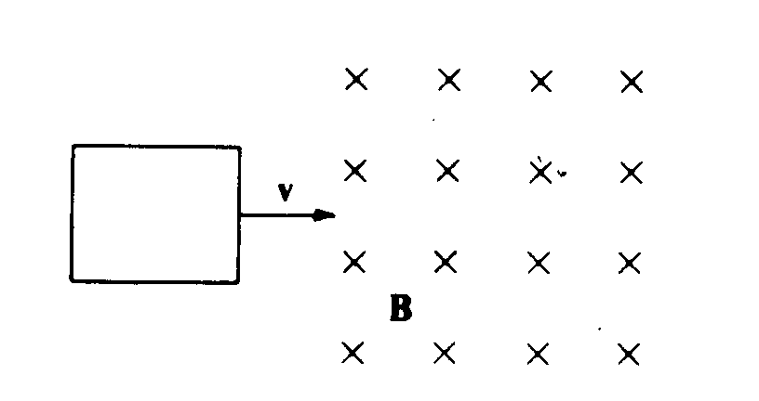
Figure 1: An object enters a magnetic field that is pointing into the page with strength 1 Tesla. Use this image to answer questions 5-7.
5. Say an electron entered a field like the one pictured in figure 1. How fast was it moving if it felt a force of 8 x 10⁻¹³ N?
5 x 10⁶ m/s
6. At what angle must the electron approach the same field (figure 1) to feel half as much force as it did in question 5?
Ø = 30º
7. At what velocity would the same electron have to approach the same field (figure 1) to feel half as much force as it did in question 6, or one fourth of the original force, when coming in at a 90º angle?
625,000 m/s
8. You see a group of 2,000 electrons traveling through a magnetic field in a circular path counterclockwise. What is the direction of the B-field from your perspective?
Out of the page towards the viewer
9. Consider the same group of electrons in question 8. What centripetal acceleration are they experiencing if they feel a force of 2 x 10⁻¹² N?
1.1 x 10¹⁵ m/s²
10. Consider the same group of electrons in question 8. What is the strength of the magnetic field if the radius of their circular path is 1 km?
v = 33149660.63 m/s
B = 1.89 x 10⁻⁴ T

Sources:
Fig 1: http://www.physicsforums.com/showthread.php?t=450662

