Lens Quiz Answer Key
Key Equations
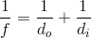
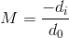
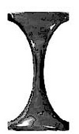
1. The image above is a:
a) Converging lens
b) Diverging lens
c) Convex Lens
d) a and c are both correct
2. Use the image below to draw in the three ray tracings. Sketch the image of the object where you think it will be and the approximate size.
Object
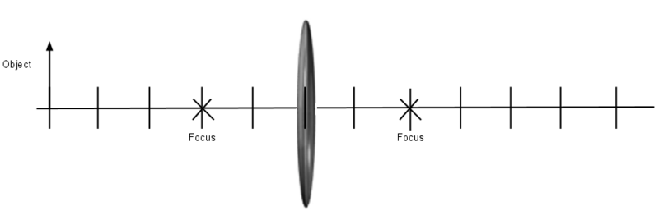
3. Is the image you drew in question 2 real or virtual?
Real
4. Is the image you drew in question 2 upright or inverted?
Inverted
5. Is the image from question 2 bigger or smaller than the original object? Calculate its magnification.
Smaller, M = 4/5 = 0.8
6. From your sketch in question 2, estimate the distance of the object away from the lens and the distance of the image away from the lens, in ‘units’.
d_{o} = 5 units, di = 4 units
7. Consider a diverging lens with focal point -10 centimeters. You have an object that is 8 cm to the left of this lens. Will the image be virtual or real, and what will be its orientation?
di = -4.44 cm, M = - 0.56. Virtual and right-side up.
8. If your grandmother needs to use a magnifying glass to read, or to see a virtual and upright image of the words, would she want to buy one with a converging lens or a diverging lens? Explain why, and explain where she would have to hold it for it to work.
Converging lens because she wants the image of the letters to look larger on her side of the lens. She would have to hold the lens at a distance smaller than the focal point.
9. What is the focal point of a window pane of glass? How do you know?
The focal point of a window pane is infinity because it will never focus the light. There is no curvature, and M = 0. We see this because the image of something behind the window has no magnification.
10. You take a converging lens outside and put it parallel to the ground. You are wearing bionic dark sunglasses so that you can see a small image of the sun forming on the ground. When you lower the lens to exactly 10 cm from the ground, there is a very sharp point of light. What does this distance represent?
This is the focal distance of this lens.

