Inelastic Collisions Quiz Answer Key

[M₁V₁ + M₂V₂]_{initial} = [M₁ + M₂] V_{2final}

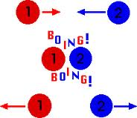
1. Which of the following images shows an inelastic collision?
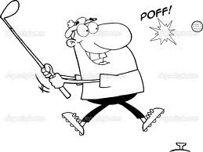
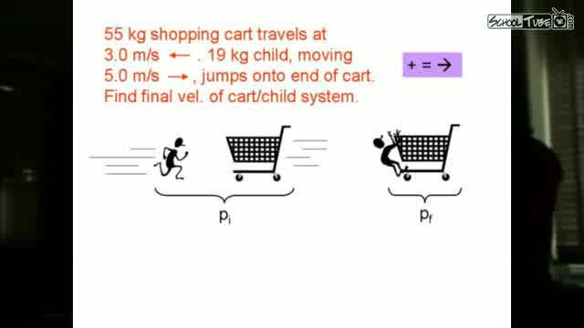
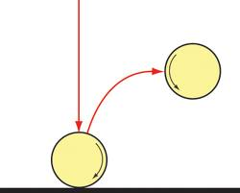

a) b) c) d)
Image Sources: http://s3.amazonaws.com/schooltube-thumbnails/20/00/4a/b8/fd/24/20004ab8-fd24-cdff-cacb-26e8029cf0d5_lg.jpg, http://www.ux1.eiu.edu/~cfadd/1150/07Mom/Images/boing.gif, http://static8.depositphotos.com/1007168/946/i/950/depositphotos_9462241-Outlined-Male-Golfer-Hitting-Golf-Ball.jpg, http://www.csiro.au/helix/sciencemail/activities/images/BounceDiagram.gif
2. Fill in the Blanks: The Law of Conservation of Momentum states that the total ____momentum_____ the objects have before a ____collision_____ must be the same as ___after the collision__.
3. Nancy Kerrigan stands in her skates on the ice rink. She has a mass of 82-kg. If someone threw a 5-kg ball at her at a speed of 18 m/s, how fast would she be moving backwards?
1.03 m/s
4. A 300 kg spaceship is floating through space at a rate of 2 m/s. An astronaut traveling in the opposite direction at a velocity of 10 m/s grabs hold of the side of the ship. The astronaut has a mass of 90 Kg. What is the new speed of the astronaut-spaceship system?
3.85 m/s

5. A 40-kg girl is running through the supermarket and jumps onto a stationary shopping cart full of groceries that has a total mass of 80-kg. They roll away together at a speed of 7 m/s. How fast must she have been running before the collision?
21 m/s

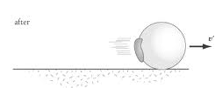
Image Source: http://img.sparknotes.com/content/testprep/bookimgs/sat2/physics/0007/gum.gif
Figure 1: A bowling ball after it rolled over a piece of gum. Use this image to answer question 6.
6. A wad of chewed gum is on the table. A 5-kg bowling ball rolls by at a speed of 3m/s and rolls over the gum, continuing to roll with it stuck to its side. The ball slowed down to 2.98 m/s. What is the mass of the gum?
0.034-kg
7. Before a collision, a 200kg Honda is driving 30m/s towards a 600kg Toyota that is not moving. After the crash, the two cars are stuck together. What is their velocity?
7.5 m/s


Image Source: http://thumbs.dreamstime.com/thumbsmall_440/1254048233hs76J2.jpg
Figure 2: A large fish swims towards a small fish and then eats it. Use this image to answer question 8.

8. A big 20 kg fish is moving to the right at a velocity of 5m/s. A little 5kg fish is moving to the left at a velocity of 2 m/s. The big fish swallows the little fish. What is the velocity of the two-fish-system after the collision?
3.6 m/s
9. In the movie Hancock, Will Smith stops a speeding train by standing in place. After the train hits him, they are both motionless.
a) Write the equation for the total momentum of the system of the train+Will before the collision, substituting for known quantities of zero, and show whether it is equal to the total momentum of the system after the collision.
[M₁V₁ + M₂V₂]_{initial} = [M₁V₁ + M₂V₂]_{final}
[M₁V_{1 initial} + 0] = 0 This is a false statement.
b) Is conservation of momentum conserved in the movie Hancock?
No.
10. If Will Smith had really tried to stop a speeding train in real life, what would have happened to him? Say the train has a mass of 780,000kg (a single train car can have a mass of 65,000 kg, so this is roughly 12 cars) and a velocity of 45m/s(which is about 100 miles per hour). If Will is 200lbs, since 1kg = 2.2lbs, his mass would be about 90kg. What would Will Smith’s final velocity actually be, and how much did he slow the train down?
[M₁V₁ + M₂V₂]_{initial} = [M₁V₁ + M₂V₂]_{final}
(780,000kg)(45 m/s) + 0 = [780,000kg + 90kg] V _{final}
V _{final} = 44.994 m/s
Will Smith slowed the train down by 0.006 m/s. He is now dead.

