Gravity and Space Problems Quiz Answer Key
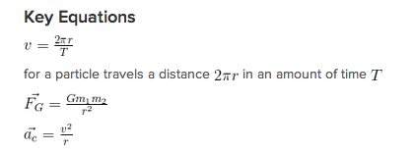
Gravitational Constant: G = 6.67 x 10⁻¹¹ m³ kg⁻¹ s⁻²
Mass of Earth: 5.97 x 10²⁴ kg
Radius of Earth: 6.3 x 10⁶ m
1. An astronaut lost her glove in space. It is now floating in geosynchronous orbit.
- What is its period of revolution?
365 days
- Calculate how far it is from Earth.
r³ = 7.53 x 10²² m³
r = 42,226,910.18 m
2. A GPS satellite cannot be in geosynchronous orbit to deliver accurate information. If its mass is 1600 kg, at what distance away from Earth should it not be floating?
r = 4.23x10⁷ m – geosynchronous orbit is independent of mass.
3. A given GPS satellite is designed to pass overhead twice every full 24-hour day in what is called a semisynchronous orbit. What is the height of its orbit above Earth?
r³ = Gm_{e}T² / 4π² = 1.834 x 10²² m³
r = 26,393,986 m = 2.64 x 10⁷ m
h = r – r_{e} = 2.64 x 10⁷ m - 6.3 x 10⁶ m = 2.01 x 10⁷ m
Combine centripetal acceleration equation with universal gravitation equation to solve for radius. Subtract the radius of Earth to arrive at the height above Earth’s surface.
4. Sirius is the brightest star in the night sky, and has a companion star that makes the system a binary. Sirius A has a mass of 4 x 10³⁰ kg while Sirius B has a mass of 1.9x10³⁰ kg. If they are 4.7 x 10¹² meters apart, which is the closest they get, what is the force binding the stars to each other?
F_{G} = 2.29 x 10²⁵ N
5. In the film 2001 A Space Odyssey, there is a circular space shuttle that rotates to simulate the force of gravity pulling the occupants towards the outside wall of the space shuttle. If it were 60 meters in diameter, at what speed would it need to spin such that the centripetal acceleration matches the strength of the acceleration of gravity on Earth?
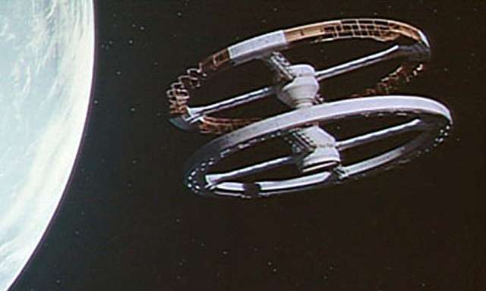
a_{c} = g = 9.8 m/s²
a = v²/r
v = 17.1 m/s
6. You are sitting in your space-house, which is 12,000-kg and floating far from any planets or stars. An apple flies by at 4 m/s. How close would the apple have to approach to be caught in a synchronous orbit?
Gm / r² = v² / r
r³ = Gm / v² = (6.67 x 10⁻¹¹ m³ kg⁻¹ s⁻²)(12,000kg) / (4 m/s)² = 5.00 x 10⁻⁸ m³
r = 0.0037m
7. Halley’s comet approaches Earth about every 75 years. Its mass is 2.2 x 10¹⁴ kg and it is the brightest comet that can be seen more than once in a human lifetime. What is the gravitational pull that Earth feels when Halley is 5.1 x 10⁹ meters away?
F_{G} = 3.37 x 10⁹ N
8. A satellite is orbiting Earth at 35,000 meters above Earth’s surface. If the satellite has a mass of 500 kilograms, what is the force between the planet and the satellite?
Don’t forget to add the radius of the earth and the satellite’s height above the earth to get the distance between them.
F_{G} = 4961.1 N
9. The mass of the sun is about 2 x 10³⁰ kilograms (wow!) and its distance from Earth is 150 million kilometers (150 x 10⁹ meters). What is the gravitational force between the sun and the Earth?
F_{G} = 3.54 x 10²² N
10. If the radius of the moon is 1.74 x 10⁶ meters, and a man with a mass of 90 kg weighs 146 Newtons on the moon, what is the mass of the moon?
F_{G} = mg = 146 N
146 N = G*(90kg) m_{moon} / (1.74 x 10⁶ m)²
m_{moon} = F_{G} r²/G m₁ = 7.36 x 10²² kg

Image 5 Source: http://www.allotment.org.uk/oldSiteImages/garden-diary/uploads/image/2009/07/2001-space-station.jpg

