Graphing Motion Quiz Answer Key
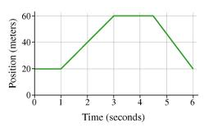
Figure 1: A graph of position versus time. Use this graph to answer questions 1-5.
1. What does this graph primarily show?
  - The displacement something is at over time
  - How fast something is going over time
  - The population growth of bears in the rainforest
  - The velocity of a tortoise
2. What is the object doing for the first second?
- Walking at a constant rate
- Accelerating
- Walking backwards
- Standing still
3. What is the moving object doing 4 ½ seconds and 6 seconds?
- Slowing down
- Accelerating
- Walking backwards
- Standing still
4. When is the moving object going the fastest? (no matter the direction)
- From 0 to 1 second
- From 1 to 3 seconds
- From 3 to 4 ½ seconds
- From 4 ½ to 6 seconds
5. To find the velocity of this object using this graph, you would have to:
- Create a new graph
- Calculate the x-axis divided by the y-axis
- Calculate the y-axis divided by the x-axis
- Add up the entire y-axis
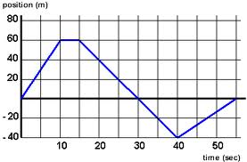
Figure 2: A graph showing a toy train’s position over time. Use this graph to answer questions 6 and 7.
6. A model train is moving along a straight track from the starting point. Using Figure 2 as a graph of the train’s position over time, when is the train’s velocity zero?
Between 10 and 15 seconds

7. Using Figure 2 as a reference, sketch a graph of the train’s velocity over the same time frame (from 0 to 60 seconds).
8
Velocity (m/s)
6

4
2
-2
60
20
50
40
30
10
-4
-6
Time (seconds)

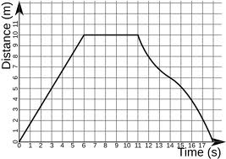
Figure 3: A Graph showing a runner’s position (distance from the starting point) versus time. Use this graph to answer questions 8 and 9.

8. A runner is trying out a new route for her workout. Using Figure 3 as a graph of the runner’s position over time, sketch a graph beneath it to represent the runner’s velocity over time.
-1
-2
Velocity (m/s)
Time (seconds)
1
0
21

5
18
10
15

9. Using your graph of the runner’s velocity, sketch a graph beneath it to represent the runner’s acceleration over time. You do not need to specify the acceleration quantities.

Acceleration (m/s²)
Time (seconds)

0

10. Sketch a graph to show the position vs. time for the following story.
One day, Savannah left her house and walked at a constant speed for 3 seconds to her car, which was 5 meters away. She stopped at her car for 1 second to look for her keys. When she found them, she drove in the same direction (away from her house) for 5 meters for 2-seconds.
Position (m)
Time (seconds)
5
10
3
6

Sources:
Figure 1: https://hockadayphysics.wikispaces.com/Position+vs.+Time+Graph
Figure 2: http://dev.physicslab.org/img/520fea3b-cc47-4f16-a8d5-539f45b0f8b6.gif
Figure 3: http://upload.wikimedia.org/wikipedia/commons/6/63/Distance-time_graph_example.png

