Free Body Diagrams Quiz Answer Key
1. Which best describes a free body diagram?
- A diagram of an object that is free of all forces
- A diagram of an object and all of the forces acting upon it
- A diagram of an object and all forces it is acting upon
- A diagram of all forces acting upon an inclined plane

2. Jeff is pulling a box towards the right using a rope.
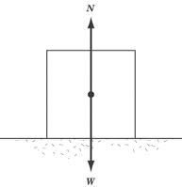

Friction
Force of Tension from Jeff pulling the rope

Image Source: http://img.sparknotes.com/content/testprep/bookimgs/sat2/physics/0010/normal.gif
a) Draw in and label the missing forces (there are at least two).
b) If the box is moving at a constant speed, write two equations that are true about the forces on this box.
W = N (or Fg = F_{N} )
F_{pull} = F_{friction}
3. Drawn below is a free body diagram of a block sliding down an inclined plane. The arrow drawn is the resultant force of all forces acting upon it. Draw in and label the three forces that are acting upon it that add up to the net force of the arrow.
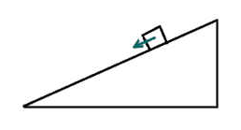
FNormal
Ffriction
Fgravity
Image Source: http://vhcc2.vhcc.edu/ph1fall9/pictures/mass_on_incline.htm
Draw a free body diagram for the following situation, remembering to include all external forces such as friction and air resistance.
4. Cinderella is sitting in her carriage as her horses pull it. The ropes that are tied to the carriage form a 26º angle with the horizontal. Sketch a free body diagram for the carriage and label all forces.
Fpull
FNormal
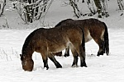
Ffriction

Fair resistance
Fgravity

5. Please inspect the following free body diagram of a block being pulled along the ground and draw a corrected diagram to the right.
FNormal
Fgravity

FNormal
Ffriction
Fpull
Fpull
Ffriction

Fgravity

6. Draw all forces acting on the small mass at the bottom of the pulley. Assume the system is at rest.
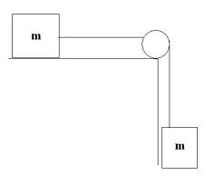
Fg
Trope

Image Source: http://media.photobucket.com/image/recent/arbilvoldy/pulley.jpg
7. Using the figure from question 5, explain what equation could be drawn from the forces in this free body diagram.
F_{g} = T_{rope}

8. Circle one mistake in the following free body diagram.
The tension in the upper rope should be pointing upwards.

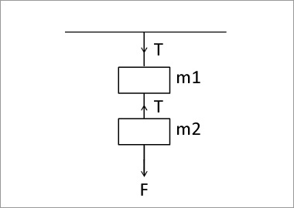
http://www.ck12.org/concept/Free-Body-Diagrams/?ref=%2Fconcept%2FFree-Body-Diagrams%2F#artifact_title
9. Draw the free body diagram of a man in an elevator that is moving uniformly upwards.
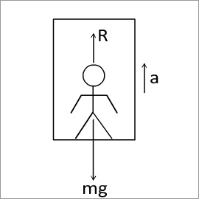
10. Draw all forces acting on masses m and M. Assume M>m and that the masses are equidistant from the ground.
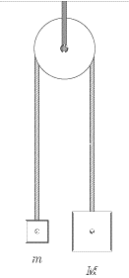
T
T
Fg = mg
Fg = Mg

Image Source: http://img.sparknotes.com/content/testprep/bookimgs/sat2/physics/0012/pulley.gif

