Electric Fields Quiz Answer Key
Key Equations
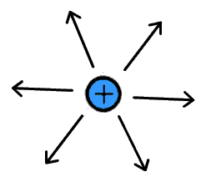
Image Source: http://www.school-for-champions.com/science/electrical_charges.htm
Figure 1: An electric field shown by field vectors. Use this image to answer questions 1 and 2.
2. Consider Figure 1. What particle is in the center (not shown), creating the field?
Proton
1. Consider figure 1. What will happen to a negatively charged electron if it entered this electric field?
- It would disappear
- It would get repelled away
- It would get attracted inwards
- This field would have no affect on an electron
3. Draw the field vectors for the following electron-proton system.

+ –
Answer:
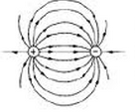
Image Source: https://6002x.mitx.mit.edu/wiki/view/MaxwellsEquations/
4. A proton is at rest, minding its own business, when someone applies an electric field in the area. The proton’s resultant motion is eastward. In which direction was the electric field pointing?
Towards the East
5. Calculate the electric field a a distance of 0.1 mm away from a cluster of electrons with charge -3 µC.
E = -0.0027 N/C
6. How strong would an electric field need to be to apply 1 Newton of force against a charge of 2 µC?
E = 500,000 N/C
7. An electric field exists near an object charged with 8 µC. What force is acting on this object if it is 0.8 nm from the charge that is creating the field?
F = 7.2 x 10¹⁸ N
8. What combination of charges would result in the following field vector? Decide if A, B, and C are any of the following: “negative,” “positive,” or “unknown.”

A C
B

A = negative
B = positive
C = positive
9. Two parallel plates placed 4 mm apart are given a voltage difference such that an electric field of 4 N/C is set up. The left plate has a positive charge and the right plate has an opposite negative charge. Which way is the electric field flowing?
Towards the right
10. Using the information from question 9, what would be the force on a -0.00003 Coulomb-charged object precisely half way between the two plates?
F = 0.00012 N

