Elastic Collisions Quiz Answer Key

[M₁V₁ + M₂V₂]_{initial} = [M₁V₁ + M₂V₂]_{final}

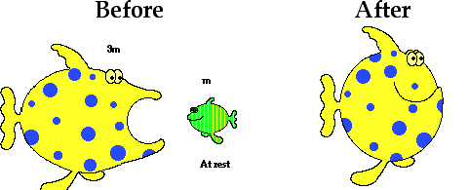
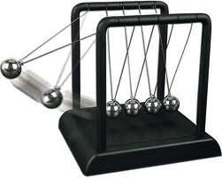
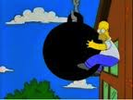
1. Which of the following images shows an elastic collision?
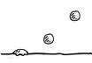

a) b) c) d)

2. James Bond is trying to escape his enemy on a speedboat. His won’t start, and is stationary in the water. His enemy, whose boat is twice the mass as Bond’s, collided with his boat at 50 m/s. If the enemy boat became completely stationary after the collision, how fast would Bond’s boat be moving due to the collision?
100 m/s
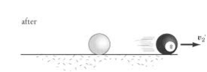
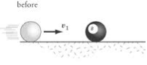

Figure 1: White cue ball hits the black 8-ball in a game of pool. Use for question 4.
3. You are playing pool with your grandfather and an interesting case happens. The white cue ball is traveling at 10m/s while the black eight-ball is sitting still. Once the white cue ball hits the eight-ball, the cue ball is staying still. Both have a mass of 0.16kg. How fast is the eight-ball going at the end?
10m/s
4. Your grandfather tries to do another trick shot at the pool table. This time, there is a red ball moving towards the corner pocket at 12 m/s just as a green ball comes rolling by at 3m/s and intercepts it. After colliding, the green ball now has a speed of 7m/s. If the pool balls both have a mass of 0.16kg, what was the final velocity of the red ball?
8m/s
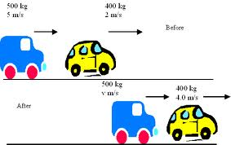
Figure 2: Your best friend rear-ended a car. Use for question 8.
5. Your best friend just got his license and accidentally rear-ended another car. Before the collision, he was driving at 24 m/s, and the car in front of him was traveling at 16 m/s. After the collision, his car slowed down to 18 m/s and the car in front of his ended up going 21m/s. If your friend’s car has a mass of 1400 kg, what was the mass of the other car? (Assume perfectly elastic collision, ignore friction.)
1,680 kg
6. Say you have a mass of 68-kg and are on a skateboard rolling at a constant 13 m/s. As you approach a sitting 0.2kg beach ball, you lean down and push it forward. If the beach ball is now rolling forward at 4 m/s, by how much did you slow down as a result of the collision?
v_{f} = 12.988m/s – I slowed down by about 0.01 m/s
7. David Akers is practicing his extra-point kicks. He kicks the football into the wall of his livingroom and it hits at a speed of 83 mph (or 37.1 m/s). If the wall did not move at all, how fast would the ball bounce back? (Assume perfectly elastic collision and ignore friction.)
37.1 m/s
8. A 0.5-kg ball rolling at 4 m/s hits a 2-kg ball dead-on. The 2-kg ball rolls away at 2 m/s at an angle of 20º from the original ball’s path. What is the velocity and direction of the 0.5kg ball after the collision? (Assume completely elastic collision and ignore friction.)
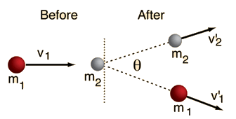
Figure 3: A red ball collides with a white one. Use for question 10.
9. A red ball rolls in along the y-axis at 4 m/s to find a white ball sitting motionless. After they collide, the white ball and red ball both split off in the y-direction as shown in figure 3, with the white ball making a 20º angle above the y-axis and rolling away at a constant 2.2 m/s. The balls have an identical mass of 1-kg. What would be the final velocity and direction of the red ball?
vf = 1.8 m/s
Direction: 49.5º from horizontal
10. Just as Serena Williams launches a tennis ball over the net, her twin Venus also launches a tennis ball back at her. Since Serena’s hit was slightly more forceful, her tennis ball was traveling at 27 m/s, while Venus’ was traveling at 24 m/s. Assuming the mass of the tennis balls was 0.057-kg each. At what speeds did the two tennis balls likely return to each athlete? (Assume completely elastic collision and ignore air resistance.)
22.04 m/s and 28.96 m/s (use conservation of kinetic energy and quadratic formula, rule out the velocity that is too high)

Images:
Fig 1. http://img.sparknotes.com/content/testprep/bookimgs/sat2/physics/0002/8ball.gif
Fig 2. http://www.antonine-education.co.uk/Image_library/Physics_4/Further_Mechanics/Momentum_5.gif
Fig 3. http://hyperphysics.phy-astr.gsu.edu/hbase/elacol.html

