Current and Magnetism Quiz Answer Key
Key Equations
1. Consider two parallel wires, one with current running South and one with current running North. What force would they have on each other?
The wires would repel each other.
2. Say a wire is coiled up into a ring, with current running clockwise through it. What would happen to all of the atoms in a metal rod that is sticking up through the ring?
Magnetic field will point downwards along the rod, all atoms/electrons would line up with it
3. An electromagnet is formed by hooking a coil of wire up to a battery (see Figure 1). If the current is flowing as shown, in which direction is the induced B-field?
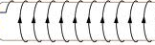
Image Source: http://commons.wikimedia.org/wiki/File:Picture_of_solenoid.png
Figure 1: A solenoid, or coiled wire, in which the current is traveling around as shown. Use this image to answer question 5.
Answer: To the left
4. A current-carrying wire is situated between the poles of a magnet, where the North pole is above it and the South pole is below it. If the current is running into the page, in which direction is there a force on the wire?
To the Left

I
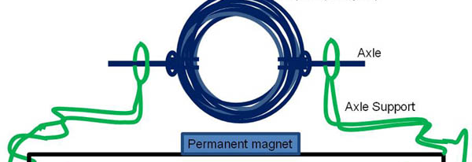
Image Source: http://www.sciencebuddies.org/science-fair-projects/phpBB3/viewtopic.php?f=26&t=11459
Figure 2: A loop of wire with current running through it from right to left. The wire is coiled from the right side up to form the top of the loop, resulting in a counterclockwise current. The magnet creates a field pointing up. Use this image to answer question 7.
5. Say a current-carrying loop is situated as shown in figure 2. If there is a magnetic field pointing upwards, which direction will the loop move?
a) Into the page
b) Out of the page
c) Top will flip out of the page, bottom into the page
- Bottom will flip out of the page, top into the page
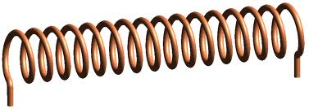
6. An electromagnet is formed from a power source and an East/West facing solenoid. If you put a compass at the opening of the solenoid, and its North-facing needle points East, draw arrows on the solenoid to indicate the direction of the current in the coiled wire.

I

Image Source: http://upload.wikimedia.org/wikipedia/commons/archive/4/45/20111209142940%21Solenoid-1.png
7. A 2-meter long wire is carrying 5 Amps of current towards the left. Someone left a magnet near the wire, which puts a downward force of 1.2 Newtons on it. In what direction is the B-field? Indicate the direction on the image below.
I

Into the page
8. Consider the scenario in question 7. What is the strength of the B-field?
B = 0.12 T
9. Consider the scenario from question 7 and 8. What length of this same wire, current, and magnetic field system must be used to create a force that holds the weight of a 2-kg current-carrying wire directly below it?
L = 3.33 meters
10. Which direction must the current be flowing in this second wire in order for it to be completely suspended by the force of the first wire?
Left, in the same direction as the original wire

