Conservation of Energy Quiz Answer Key

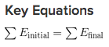
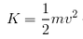
1. Fill in the blanks: Energy __conservation____ means that energy is never created or destroyed. Energy never disappears, it is always __transferred___ from one type to another.
2. As a ball falls from up high down to the ground, it
  - Gains kinetic energy and loses potential energy
  - Gains potential energy and loses kinetic energy
  - Gains both kinetic and potential energy
  - Loses both kinetic and potential energy

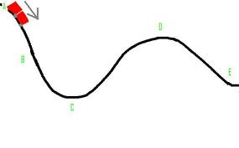
Image Source: http://www.unc.edu/~ncspence/physics101/Energy%20Transfer.htm
Figure 1: A roller coaster car has just passed the hill of the first big drop. Use this image to answer questions 3-5.
3. Using figure 1, at which point on the track would the car have the most kinetic energy?
C
4. Using figure 1, at which point on the track would the car have the most potential energy?
A
5. Using figure 1, at what point is potential energy zero, and at what point is kinetic energy zero?
C, A
6. One of the Lady Spartans was falling to the ground after dunking the winning basket. At the end of her fall, she was falling at 4 m/s. If she was 60kg, how much potential energy did she have at the top of her jump?
480 J
7. If a 0.5 kg ball is on top of a ramp that is 8 meters high, how much kinetic energy does it have at the bottom of the ramp?
40 J
8. A monkey was swinging from a branch like a pendulum. It had a mass of 10 kg and when he was at the lowest point of his swing, he was going 5 m/s. How high was the monkey when he started at the highest point of his swing?
h = PE/mg = KE/mg = ½ m v² /mg = ½ 25/10 = 1.25 meters
9. If you are on a half-pipe or are rolling down a ramp, you can raise your speed by starting higher up on the ramp or half-pipe. Why does the height affect your Kinetic Energy?
Because the higher you are the more total energy you have because your potential energy depends on height. The kinetic energy depends on potential energy.

10. A ball starts at rest at the top of the ramp. Fill in the blanks with the missing amounts of energy of the ball at different heights along the ramp. Ignore friction and air resistance.

PE = 100 J
KE = _0J_

PE = _50J_
KE = _50J_

h=100m
h=50m
PE = _0J_
KE = _100J_

