Centripetal Force Problems Quiz Answer Key
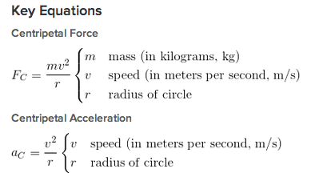
1. Write an equation for the forces acting on a car with mass M that is skidding around a curve of radius r at a velocity v. Assume a coefficient of kinetic friction µ_{k}.
Fc = Ffr
mv²/r = µ_{K}mg
2. The centripetal force on an object does NOT always depend on
- Its tangential velocity
- What object is pulling it
- Its distance from the object pulling it
- None of the above – centripetal force always depends on a, b, and c.
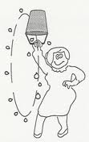
Image Source: http://fouryears.eu/2009/02/12/the-great-swinging-bucket-conspiracy/
Figure 1: A bucket holds 2-kg of water. Aunt Sandy is swinging it up and down in a circle that is 2-meters in diameter, so that it is upside down for the top half of its path. Use this figure to answer questions 3 and 4.
3. Sandy wants to swing it at the minimum angular speed. What is the velocity needed to keep the water in the bucket, remembering that the centripetal force has to overcome the force of gravity?
mv²/r = mg, v² = g•r
v = 3.13 m/s (or about 3.16 m/s)
4. As you calculated the necessary centripetal force for the water to stay in the bucket, what did you notice about the equation with regards to the mass?
The mass canceled out which means it doesn’t matter how massive the water is, just how far away from the center it is.
5. You are on a roller coaster and you are making a sharp turn with radius 19 meters. Your accelerometer tells you your tangential velocity is 45 mph (20.1 m/s). What force do you feel against the side of the coaster if you weigh 80-kg?
Fc = 1,701 N
6. A 2000 kg car is speeding around a flat curve of radius 40 meters. The coefficient of kinetic friction between the car and the road is 0.7. How fast can the car drive without slipping off the road?
Fc = Ffr, mv²/r = µF_{N}
mv²/r = µmg
v_{max} = 280 m/s
7. Your physics teacher has attached a 0.2-kg ball at the end of a taught string that is 1.4 m long. She begins to spin it over her head like a lasso at 2 revolutions per second. What is the tension in the string?
T = Fc = mv²/r = m (w•r)² / r = (0.2-kg)(4rev²/s²) (0.7m) = 0.56 N

8. Imagine your physics teacher takes the same string-ball-combination from question 6 and begins to swing it up and down in a circle like Aunt Sandy did (see Figure 1). The ball was moving at 4 m/s.
a) Draw and label the forces on the ball when it is at the top-most part of its path.
Fg
Fc

Fg
Fc

b) Draw and label the forces on the ball when it is at the bottom-most part of its path.

c) What is the tension on the string at the top-most point?
T = Fc + mg
= mv²/r + mg = (0.2kg)(4m/s)²/1.4 m + (0.2kg)(9.8m/s²) = 6.53 N
d) What is the tension on the string at the bottom-most point?
T = Fc – mg = 2.61 N
e) Where in the ball’s path would the string most likely snap and cause the ball to go flying?
When the ball is at the top of its path.
9. You are on the fastest roller coaster that has a loop with radius of 18 m. At the top of the loop you are completely upside down. How fast must the coaster be traveling to ensure that you won’t fall out?
Fc = mg
v²/r = g
v = (rg)^{-1/2} = 13.3 m/s

10. If most roller coasters travel between 50-100 miles per hour and have loops that are between 15 and 20 meters, are you safe?
YES

