Centripetal Acceleration Quiz Answer Key
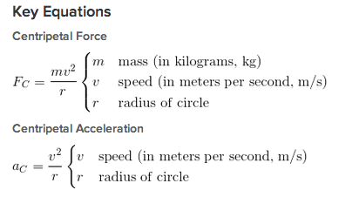
Approximate distance from the Earth to the Sun: 1.5 x 10¹¹ meters
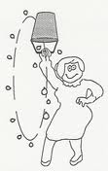
Fg
Fpull
a
Image Source: http://fouryears.eu/2009/02/12/the-great-swinging-bucket-conspiracy/
Figure 1: A bucket holds 2-kg of water. Aunt Sandy is swinging it up and down in a circle that is 2-meters in diameter, so that it is upside down for the top half of its path. Use this figure to answer questions 1-4.
1. On Figure 1, draw arrows showing the forces acting on the bucket and water, and a double-arrow to show the overall direction of acceleration.

2. If the bucket made 3 revolutions per second, what is the centripetal acceleration of the bucket?
v = w • r, v = 3 m/s
a = v² / r = 9 m/s²

3. How can Aunt Sandy increase the centripetal acceleration of the bucket? Name two methods.
Swing it faster or shorten the radius/handle
4. In which direction is the net acceleration of the water bucket when it is at the top of its path (above her head)? Is the water bucket accelerating in that direction? Explain.
Net acceleration is downwards. Yes, the water bucket is accelerating downwards, which means its velocity is changing to be more towards the center of the circle, though it was already moving with a sideways velocity.
5. If an ant is standing on a cd 4 centimeters from the center, and it covers 8cm in every second, calculate its centripetal acceleration in m/s².
a = v²/r = (.08m/s)² /4 = 0.0256 m/s²
6. Your little sister is on the outside edge of a merry-go-round. She is spinning past you once every second. What is her centripetal acceleration if the merry-go-round is 2 meters across?
r=1m, w = 2π/(1s) = 2π/s, v = wr = (2π)(1) m/s
a = (2π m/s)² / 1m = 39.48 m/s²
7. If you are on a roller coaster turning a sharp curve. You brought your accelerometer along and it reads that your centripetal acceleration is 40 m/s². If you estimate that the radius of the curve is 10 meters, about what velocity are you traveling?
a = v²/r, v = (ar)^{1/2} = (40 m/s²•10m)^{1/2} = 20 m/s
8. What is the velocity of the Earth as it orbits the Sun?
1 orbit in 365 days = 31,536,000 seconds, r = 1.5 x 10¹¹ meters
w = 2π/31,536,000s = 0.0000002/s
v = wr = (0.0000002/s)(1.5 x 10¹¹m) = 29,885.77 m/s
9. What is the centripetal acceleration of the Earth as it orbits the sun?
a = v²/r = 0.006 m/s²

10. Spiderman is escaping from Doctor Octopus. He attaches his web to the corner of a building and falls 18 meters. He swung a distance of 40 meters along a curved path in 3 seconds. What was his angular acceleration?
Ø = 40m/18m = 2.33 rad
w = (2.33)/3 sec = 0.77/s
v = wr = (0.77/s)(18 m) = 14 m/s
a = 196 m²/s² / 18 m
= 10.9 m/s²

