Capacitors in Series and Parallel Quiz Answer Key
Key Equations
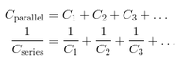
1. Adding more capacitors to a circuit in parallel would
a) Add to the total capacitance of the circuit
b) Detract from the total capacitance of the circuit
c) Add to the total resistance of the circuit
d) Detract from the total resistance of the circuit
2. What would be the total capacitance of a circuit with three 5 µF capacitors wired in series?
C = 5/3 µF = 1.67 µF
3. What would be the total capacitance of a circuit with three 5 µF capacitors wired in parallel?
C = 15 µF
4. Compare your answers to questions 2 and 3. If you wanted to create a circuit that stored the most energy possible, how woud you wire your capacitors?
In parallel
5. What would be the total capacitance of a circuit with two 6 µF capacitors in series and one 10 µF capacitor in parallel?
C = 13 µF

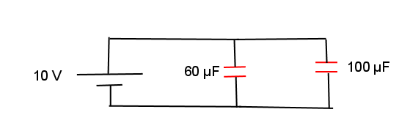

30 µF
25 µF
20 V

Figure 1: Parallel circuit with two capacitors. Use this figure to answer questions 6 and 7.
6. Consider the circuit above. Calculate the total capacitance.
C = 55 µF
7. Calculate the charge stored in each of the capacitors.
Q₁ = VC₁ = 500 µC
Q₂ = VC₂ = 600 µC
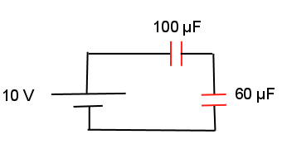
15 V
40 µF
15 µF
15 µF

Figure 2: A circuit with capacitors in series and in parallel. Use this figure to answer questions 8, 9 and 10.

8. Consider the circuit above. Calculate the total capacitance.
C_{tot} = 17.14 µF
9. Calculate the total charge stored in all of the capacitors combined.
Q_{total} = VC = (15V)(17.14 µF) = 257.1 µC
10. What is the voltage drop across the 40 µF capacitor?
V_{40µF} = 6.43 Volts

