Capacitors Quiz Answer Key
Key Equations
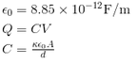
1. How is a capacitor like a battery, and how is it different?
They both store energy, but a battery will store it long term and a capacitor will release it.
2. Sketch a simple capacitor with a voltage drop of 10V, and label the voltages. Next to it draw the electrical circuit symbol.
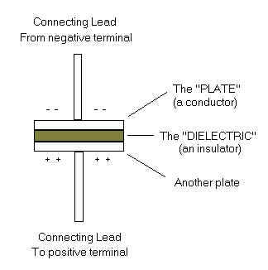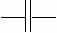
-5 V
+5 V
Image Source: http://www.qsl.net/ng3p/haminfo/ham-tutor/circuit_components.htm
3. Explain why a capacitor needs plates with a larger area in order to hold more charge.
All positive charges gather on one plate and all negative charges gather on the other. The negative charges are all repelling each other, so the more space they have, the more negative charges can gather in the capactior.
4. If no electricity flows between the two plates of a capacitor, explain how piling negative charges on one plate will result in multiple positive charges building up on the other plate.
All of the electrons on the opposite plate will be repelled away and all of the positive charges will be attracted through the space between the plates and will stay.
5. Draw the atoms of the dilectric substance and how they would orient themselves to reduce the Electric field between a capacitor’s plates.
+ + + + + + + + + +

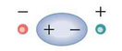
- – – – – – – – – – – –
Image Source: http://cnx.org/content/m42333/latest/?collection=col11406/latest

6. Why are capacitors usually in a cylindrical shape?
They can store more charge with more area, so the plates are rolled up to fit a large area in a smaller space.
7. How does doubling the dilectric constant of the material between the plates affect how much charge a capacitor can hold? What technology could help capacitors be more effective?
It would double the amount of charge. Finding a material that has an extremely high dilectric constant would greatly increase the amount of charge we could store.
8. What is the capacitance of a capacitor with plates that measure 1cm by 1 cm and have 1 mm of air between them?
C = 8.85 x 10⁻¹³ F.
9. Using the information from question 8, calculate the charge this capacitor could hold if you applied a voltage of 30 Volts. Is this a lot of charge or not?
Q = 2.66 x 10⁻¹¹ C. This is very little.

10. What distance away would you place two 3-mm capacitor plates in order to be able to store 100 C when 120V is applied? Is this possible?
d = 9.56 x 10⁻¹⁷ m apart – this is not possible to physically build.

