Capacitors Circuits Quiz Answer Key
Key Equations
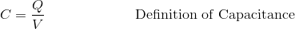

1. Consider a capacitor and a voltage source wired in series with no resistance. Describe what happens to the moving charge as the voltage source is turned on or up.
The charge comes from the voltage source and all the negative charge gathers on one side of the capacitor, and positive charge builds on the other side, until the potential difference across the capacitor is equal to that of the voltage source.
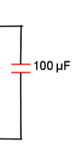
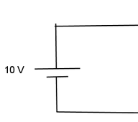
2. Assuming the figure below represents a circuit that has a live current, draw the charges onto the circuit where they would be located.

3. Choose the correct answer.
a) Two capacitors wired in series will have the same voltage
b) Two capacitors wired in series will have the same charge
c) Two capacitors wired in series will have the same capacitance
d) None of the above; every two capacitor combination will be different.

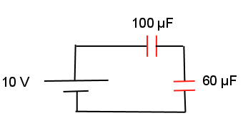
15 V
40 µF
35 µF
10 µF

Figure 1: A circuit with capacitors in series and in parallel. Call the 40 µF capacitor C₁, the 10-µF capacitor C₂, and the 35-µF capacitor C₃. Use this figure to answer questions 4 through 10.
4. Find the equivalent capacitance of the circuit in figure 1.
C = 21.18 µF
5. How would you alter the capacitance of C₃ to give the circuit a higher equivalent capacitance?
Raise it
6. Which two capacitors in figure 1 have equivalent voltages?
C2 and C3
7. What is the total charge on the circuit?
Qtot = CtotVtot = 21.18 µF * 15 V = 317.7 µC
8. Write an equation that gives a relationship for the charges of all three capacitors, simplifying as much as possible, and use it to solve for the charge of C₁.
Qtot = Q1 + Q2 + Q3 = 317.7 µC
Q23 = Q2 + Q3 (wired in parallel)
Assume C2 and C3 are one capacitor, then C23 is wired in series with Q1.
317.7 µC = Q1 = Q23
Q1 = 158.85 µC
9. Using your answer to question 7, what is the voltage difference across C1?
V1 = Q1/C1 = 158.85µC/40µF = 3.97 Volts
10. Write an equation that gives a relationship for the voltages of all three capacitors, simplifying where possible, and use it to solve for the voltages of C₂ and C₃.
V = V1 + V2 + V3 = 15 V
V2 = V3
3.97 Volts + 2V₂ = 15 Volts
V₂ = V₃ = 5.51 Volts

