Beat Frequencies Quiz Answer Key
Key Equations
f_{beat} = ⎜f₁ - f₂ ⎜
1. Fill in the blanks: If two waves cancel each other out completely, this is an example of ___destructive_____ interference.

2. What is the beat frequency of two keys on the phone, one with frequency 200 Hz and one with frequency 280 Hz?
80 Hz
3. You notice the car in front of you has its turning signal on, and it very nearly matches your car’s turning signal. Every 16 seconds they are exactly on beat with each other. What is the beat frequency of your two signals?
f_{beat} = 0.0625 Hz
4. Two friends are playing a duet. From the audience you notice they are slightly off-key from each other as they both try to play a C-note, and producing a beat frequency of 1.1 Hz. One floutist is playing on key at 261.6 Hz. What frequencies can the second person possibly be playing?
260.5 Hz or 262.7 Hz
5. The frequency of one tuning fork is 300 Hz. The other tuning fork has a frequency of 340 Hz. How often will you hear a high-pressure beat?
40 times per seconds
6. A martian is flashing his flashlight at Earth once every 2 seconds. You want to return the signal so that the two signals “beat” together at a frequency of 0.2 Hz. How often should you flash your light?
Once every 3 seconds
7. Two waves interfering with each other results in constructive interference if:
- The two waves are the same frequency
- The peaks of both waves line up
- The peak of one wave lines up with a trough in the other wave
- The two waves are from the same source
- All of the above
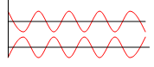
Image Source: http://www.schubincafe.com/tag/sine-wave/
Figure 1: Two waves whose frequencies interfere. Use this image to answer questions 8.
8. Examine the image of two different waves in Figure 1. If these two waves interfere wth each other, what will the resultant interference wave look like? (Sketch it.)
Answer: 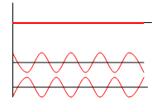
Image Source: http://www.schubincafe.com/tag/sine-wave/

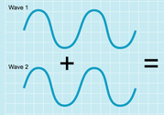
Image Source: http://astro-canada.ca/_en/a2313.php
Figure 2: Two waves whose frequencies interfere. Use this image to answer questions 9.
9. Examine the image of two different waves in Figure 2. If these two waves interfere wth each other, what will the resultant interference wave look like? (Sketch it.)
Answer: 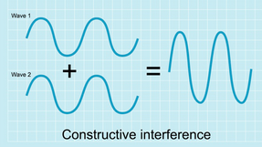
Image Source: http://astro-canada.ca/_en/a2313.php

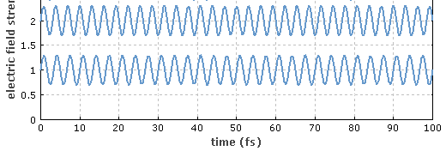
Image Source: http://www.rp-photonics.com/img/beat_note.png
Figure 3: Two electric field waves that interfere to create a beat frequency. Use this image to answer question 10.
10. Find the approximate beat frequency for the two waves in figure 3. (Find peaks that are located at a measurable time so that you can estimate how long each cycle takes. Then find each wave’s frequency.)
f₁ = 0.325 Hz, f₂ = 0.3 Hz
f_{beat} = 0.025 Hz
Image Source: http://www.rp-photonics.com/img/beat_note.png

